
REPUBLIC OF GHANA

MID-YEAR COMPOSITE BUDGET

FOR 2025-2028

PROGRAMME BASED BUDGET ESTIMATES

FOR 2025

KETU SOTH MUNICIPAL ASSEMBLY


The 2025 Mid-Year Composite Budget was approved at the First Ordinary Meeting of the First Session of the Ninth Assembly of the Ketu South Municipal Assembly, held on August 13th, 2025.

The motion for the approval of the 2025 Mid-year Composite Budget was moved by Torgbui Hodah Alagbah IV and was seconded by Hon. Mawutor kpetsigo

Mr. BENJAMIN K. TETTEY HON. RICHARD S. NYARVIE HON. NICHOLAS K. WORCLACHIE
AG. MUN. COORD. DIRECTOR PRESIDING MEMBER MUN. CHIEF EXECUTIVE

Compensation of Employees Goods and Services Capital Expenditure
GH¢ 8,282,399.00 GH¢ 11,221,036.00 GH¢ 31,636,143.00

Operation and Maintenance GH¢
Total Budget GH¢ 3,163,614.30
Table of Contents
PART A: STRATEGIC OVERVIEW OF THE ASSEMBLY 4
Establishment of the District 4
Population Structure 4
Vision 4
Mission 5
Goals 5
Core Functions 5
District Economy 6
Key Issues/Challenges 11
Key Achievements in 2024 12
Revenue and Expenditure Performance 14
Adopted Medium Term National Development Policy Framework (MTNDPF) Policy Objectives 17
Policy Outcome Indicators and Targets 18
Revenue Mobilization Strategies 19
PART B: BUDGET PROGRAMME/SUB-PROGRAMME SUMMARY 22
PROGRAMME 1: MANAGEMENT AND ADMINISTRATION 22
PROGRAMME 2: SOCIAL SERVICES DELIVERY 36
PROGRAMME 3: INFRASTRUCTURE DELIVERY AND MANAGEMENT 48
PROGRAMME 4: ECONOMIC DEVELOPMENT 54
PROGRAMME 5: ENVIRONMENTAL MANAGEMENT 59
PART C: FINANCIAL INFORMATION 64
PART D: PROJECT IMPLEMENTATION PLAN (PIP) 65

PART A: STRATEGIC OVERVIEW OF THE ASSEMBLY

Establishment of the District
Ketu South Municipality is one of the eighteen (18) municipalities/districts in the Volta Region of Ghana. The Municipality is located at the south-eastern corner of Ghana. It shares boundaries with the Republic of Togo to the East, Keta Municipality to the West, Ketu North Municipal to the North, and the Gulf of Guinea to the South. The Municipality has a total land size of approximately 279.64 sq. km, representing 3.8 per cent of the regional land area and lies within latitudes 60 03’N and 60 10’N, and longitude 10 6’E and 10 11’E. The Municipality is strategically located with the added advantage as the Eastern Gateway to Ghana, where continuous cross-border activities are carried out daily. The location of the Municipality to the main Ghana-Togo border, coupled with its socio-economic potentials, brings to the fore some critical development opportunities for investors to tap into.

The Ketu South Municipality was formerly created by an Act of Parliament in 2007 through the Legislative Instrument (LI) 1897 of 2007, which split Ketu into Ketu North and Ketu South. In 2012, Ketu South Municipality was elevated to a Municipal status through LI 2155 of 2012 with 57 Assembly Members.

Population Structure
The 2021 Population and Housing Census recorded a total population of 253,122, with females dominating by 52.1 per cent, while males constitute 47.9 per cent. With a growth rate of 2.4 per cent, the population is currently projected to reach 272,019 and 278,626 by the end of 2024 and 2025, respectively. The population of the Municipality constitutes 15.3 per cent of the population of the Volta Region.

Vision
Ketu South Municipal Assembly’s vision is to be the best-managed and decentralized assembly delivering superior client-oriented services.

Mission
Our mission statement is to make a positive change in the Ketu South Municipality by mobilizing available fiscal, material and human resources for efficient and effective delivery of social, economic, political and cultural services through the application of science, technology and transformational leadership.

Goals
To attain the best decentralized public services through effective development and harnessing available resources in a participatory manner in the municipality.

Core Functions
The Local Government Act, 2016, Act 936, spells out the functions of MMDAs, which include:
1. The Assembly is the highest political and administrative authority in the Municipality and accordingly promotes local economic development and provides guidance, and gives direction to and supervises other administrative authorities in its jurisdiction.
2. The Assembly exercises three (3) statutory functions which are deliberative, legislative functions and executive functions.
3. The Municipality shall;
(a) be responsible for the overall development of the municipality;
(b) ensure the appropriate and adequate preparation and submission through the Regional Co-ordinating Council of;
i) development plans of the municipal to the commission for approval;
ii) the budget of the municipal related to the approval plans to the Minister for Finance for approval.
(c) Formulate and execute plans, programs, and strategies for the efficient mobilization of resources necessary for the overall development of the municipality.
(d) Promote and support productive activities and social development in the municipality and remove any obstacles to initiative development.
(e) Sponsor the education of students from the district to fill particular manpower needs of the district, especially in the social sectors of education and health, making sure that the sponsorship is fairly and equitably balanced between male and female students;
(f) Initiate programmes for the development of basic infrastructure and provide municipal works and services in the municipality.
(g) Be responsible for the development, improvement and management of human settlements and the environment in the municipality;
(h) In cooperation with appropriate national and local security agencies, be responsible for the maintenance of security and public safety in the municipality;
(i) Ensure ready access to the courts and public tribunals in the municipality for the promotion of justice;
(j) Act to preserve and promote the cultural heritage within the district;

District Economy
The economy of Ketu South Municipality is driven largely by agriculture, manufacturing and commerce.
The municipal economy has been further subdivided into smaller sections, such as in the areas of Agriculture, Education, Tourism, etc. These are discussed and explained below;
- Agriculture
The Agricultural sector is the single most important economic sector in the Ketu South municipality, employing over 18 per cent of the labour force according to the 2021 Population and Housing Census. 98% of the total farmlands in the municipality are under subsistence farming. The agricultural sector is divided into three sub-sectors: Crop, Livestock and Fisheries, of which the Fisheries sub-sector has become the dominant, representing 30% of the total agricultural activities. Some of the agricultural products cultivated are outlined below
Groups Examples
Plantation crops Coconut
Subsistence food crops Maize, Cassava and vegetables
Non-traditional crops Mango, Chilli pepper
Urban Vegetable products Onion, Butternut, Chillies, Okro, Tomatoes, Carrot and “Gboma”
Livestock Poultry, Goats, Sheep, Pig, Grass-cutters
Fisheries Pelagic fish etc

- Road Network
The Municipality has approximately a total of 160km of road network, consisting of highways (27km), urban roads (28km) and feeder roads (103km). Out of these roads, a distance of 20km has been asphalted whiles 16km is bitumen surfaced. Also, almost 81km of the roads are gravelled/shaped of concern is the remaining stretch of feeder roads (43km), which are not motorable, particularly during the rainy season.

- Health
The administration of the health sector is demarcated as sub-districts among the five (5) Zonal councils, namely Aflao East, Aflao West, Aflao Wego, Klikor, Some Fugo and Some Wego. Hence, there are six (6) health-demarcated sub-districts. As of 2022, KSMA had five (5) hospitals, four (4) been private and one (1) Public, eight (8) health centers, five (5) private clinics and 18 CHPS compounds. However, most of these health facilities are concentrated in the urban areas of the Municipality.

- Education
The Ketu South Municipality has 10 circuits and 230 public basic schools and 181 recognized private basic schools. Out of these, there are 137 kindergartens, 157 primary schools, 74 Junior High Schools, 5 public and one (1) private Senior High Schools, and one (1) Technical/Vocational school.

- Market Centres
Ketu South municipality has five major market centres that attract sellers and buyers from all parts of Ghana and the Republic of Togo. Commerce in Ketu South is both vibrant and exuberantly hinged on the concept of market rotation. These market centers are located in Hedzranawo, Wudoaba, Agbozume, Gakli and Aflao. Market days are held on a rotational basis every four (4) days. Other satellite markets are found in Denu and Aflao, which are held mostly daily. The major markets specialize in selling fish especially smoked herrings and agricultural produce. The Border market of Aflao is a commercial distribution centre for agricultural produce from the Western, the Brong-Ahafo, the Eastern and the Central regions of Ghana. These goods are subsequently exported to Togo.

- Water and Sanitation
- Water
Although the Municipality has a few fresh groundwater bodies, it is endowed with abundant underground water. Thus, all potable water available to the populace is sourced from high-yielding underground water systems known as Small Town Water Supply Schemes. Notable among these are the Coastal Communities Water Supply Scheme (which stretches from Aflao/Denu to Blekusu), Nogokpo Communities Water Supply Scheme, and Klikor Communities Water Supply Scheme. Management of these schemes falls under the supervision of the Community Water & Sanitation Agency (CWSA), except that of Aflao, which is directly managed by Ghana Water Company Limited (GWCL).

Data on the main source of potable water shows that, pipe born water accounts for 66.7 per cent, followed by river/stream (21.5%). Borehole/Pump/Tube well water (0.4%) forms the least used source of water by households. For the source of potable water by locality, Pipe born water is the most used in urban areas (96.7%) than in rural areas (61.5%). Also, the use of River/Stream is predominant in rural areas (25.1%) than in urban areas (0.4%). This implies communities without potable water stand a risk of suffering from water-borne diseases and also covering long distances to access potable water.

- Sanitation
The Municipality, like other municipalities in Ghana, continues to face sanitation management challenges, especially concerning solid waste. In spite of the fact that there is no readily available data on waste generation in the municipality, Aflao remain on top of the list due to the influx of thousands of migrants and brisk commercial activities in the municipal capital daily. However, structures are in place to manage the situation and prevent any disease outbreak of public concern through the services of Zoomlion and Volta Waste Landfills Ltd, who both manage solid and liquid waste in KSMA under the supervision of the Municipal Environmental Health Officer.

Environmental sanitation cuts across all sectors of the economy, including those that concern health, environmental protection, improvement in human settlements and services, tourism and general economic productivity. Addressing the poor behaviour and attitude towards environmental sanitation is a critical area of concern for achieving Sustainable Development Goal 6 of ensuring environmental sanitation sustainability. Environmental sanitation encompasses activities such as the provision and maintenance of sanitary facilities, the provision of services, public education, community and individual actions.

- Tourism
There is great potential for tourism development in the Municipality. Significant among them are the coastal sea shore for beach development, a large track of lagoon land with potential for eco-tourism, a vibrant kente industry, rich traditional festivals and a buoyant hospitality industry. There are a number of beach fringes with coconut trees along the coastline stretching from Aflao to Blekusu. The beaches are potential tourism sites for holidaymakers.

- Industry
Two major heavy industries dominate the manufacturing sector in Ketu South Municipal Assembly. These have been highlighted below;

a. Diamond Cement Factory
The Ketu South Municipality has one of the largest cement factories in Ghana. The Diamond Cement Factory was established in the year 2001. The factory has a production capacity of 1.8million tones per year. It distributes its products to Ghana, Togo and Benin. Diamond Cement Factory employs over 600 people majority of whom are natives of the Municipality.

b. Salt Mining Industry
Salt mining is one other major economic activity for the people in Taskcorner, Adina, Agavedzi, Blekusu, Amutinu, Dogbekope, Sonuto, Tagbato and Dzaglame, which is carried out on a small-scale basis. However, the Seven Seas Salt Company Limited is the only company which is currently operating within the municipality that takes its raw materials from the Ketu South. Though fraught with operational challenges in the area of their relationship with the communities, the Assembly has managed to step in to resolve the issues as and when it raises its head. Currently, the operation of the company is in the white do’or concession.

Again, the other industries that exist in the municipality include the Kente industry, the Phosphate industry, and the small-scale industrial activities in food processing, alcoholic beverages, manufacturing and service industries.

- Environment
Natural Disaster
The disaster-prone areas in the municipality includes Aflao Central, Agorkpanu, Denu, Aflao Wego, Kpoglu, Avoeme-Viepe, Adina-Blekusu, Some Wego, Klikor Central and Klikor West. These areas are considered disaster prone area in view of occurrences of one or more of the following; flood, tidal waves, windstorm and fire, which mostly have adverse effects in the communities that are mostly affected.

- Banking Services
There are eight (8) banks and seven (7) micro-credit/financial institutions operating in the Municipality. These are the Ghana Commercial Banks, United Bank of Africa (UBA), ECOBANK and GT Bank located at Aflao, and the Agricultural Development Bank (ADB) at Denu. There is also a branch of the Avenor Rural Bank located at Denu and Unity Rural Bank located at Aflao. In addition, other credit and loans schemes are available across the municipality to support economic activities. These financial institutions provide credit to promote agricultural production as well as commercial activities in the municipality. However, large sections of the population lack access to credit because of the strict collateral requirements and most especially weak entrepreneurial acumen.

- Natural Disaster
The disaster-prone areas in the municipality includes Aflao Central, Agorkpanu, Denu, Aflao Wego, Kpoglu, Avoeme-Viepe, Adina-Blekusu, Some Wego, Klikor Central and Klikor West. These areas are considered disaster prone area in view of occurrences of one or more of the following; flood, tidal waves, windstorm and fire, which mostly have adverse effects in the communities that are mostly affected.

Key Issues/Challenges
1. Limited availability and accessibility of economic Data
2. Inadequate modern markets
3. Inadequate school infrastructure
4. Inadequate access to water services in urban and rural areas
5. Low awareness of child protection and family welfare laws and policies
6. Potential rise in sea level resulting in wetland flooding
7. Improper disposal of solid and liquid waste
8. Inadequate spatial plans

Key Achievements in 2024
Constructed market shed at Aflao market Training of Assembly members
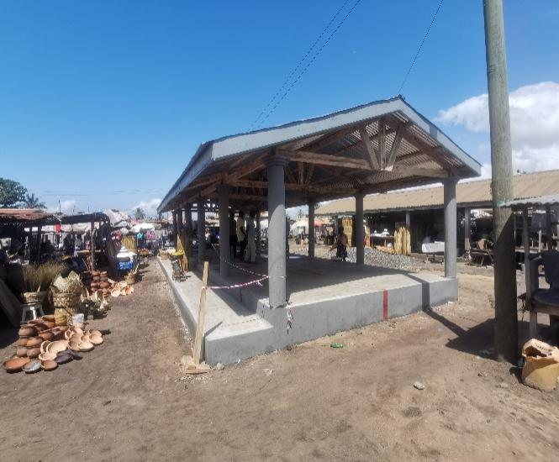
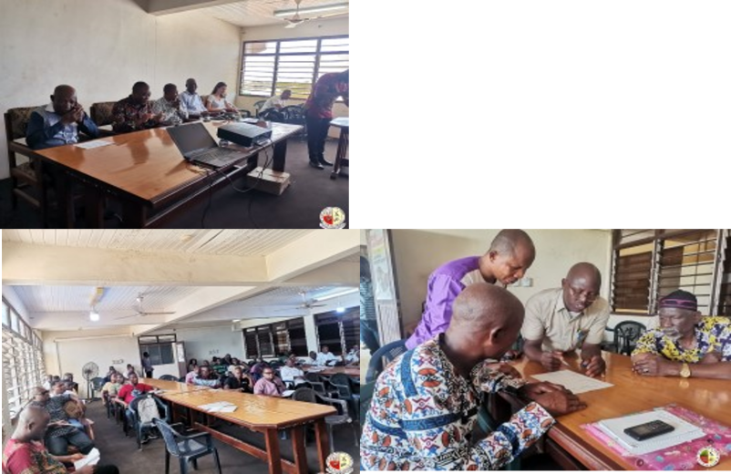

Distribution of revenue generating items to PWDs
Supplied 650 dual desk to schools
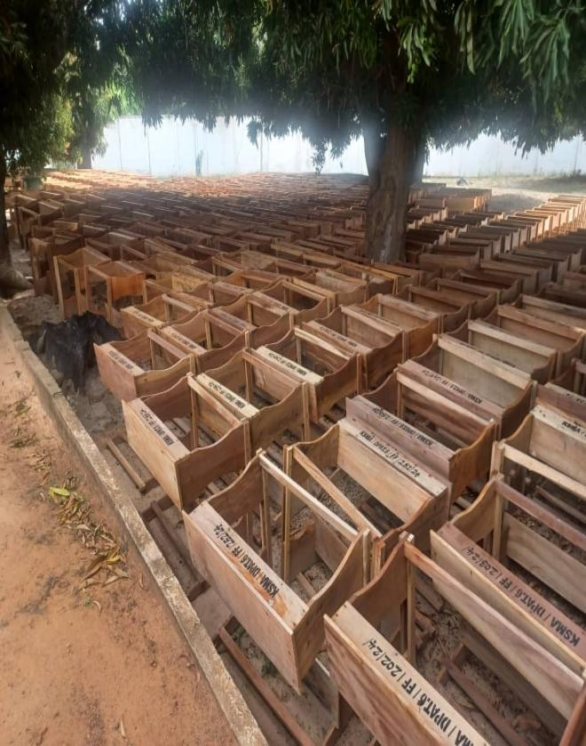
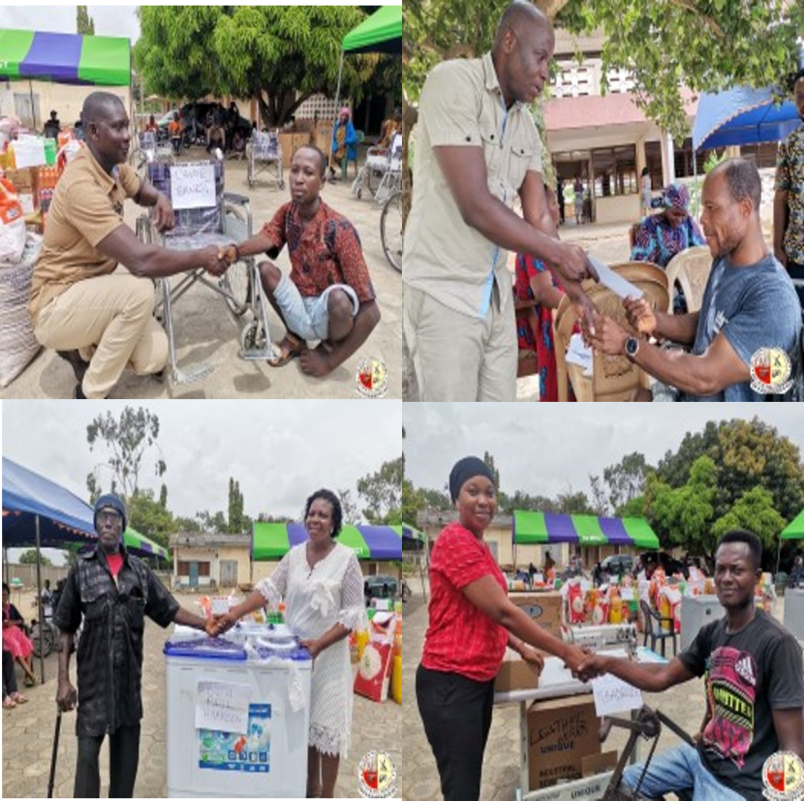

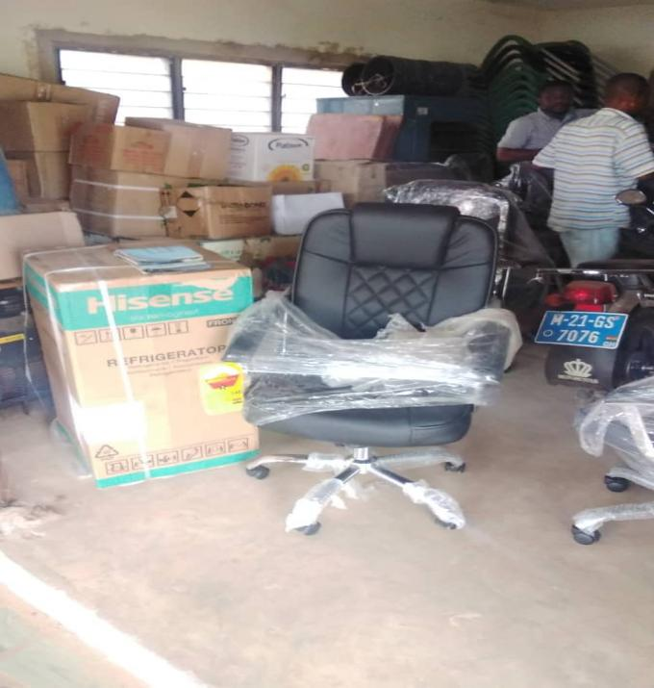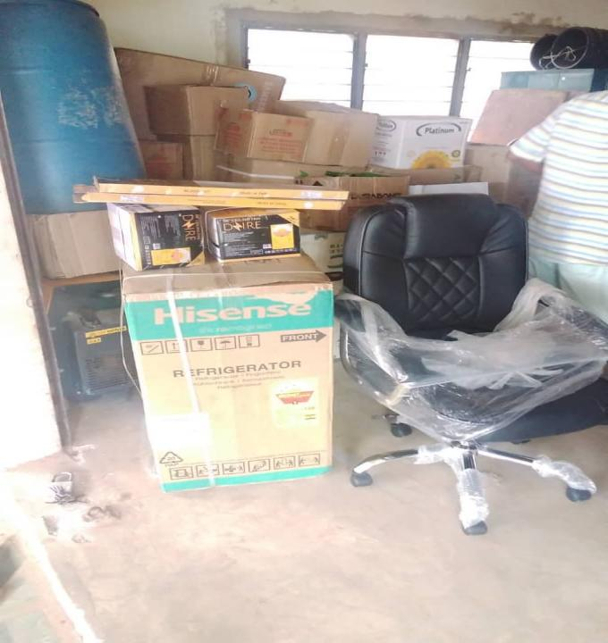
Procurement of Stationary for Aflao Police station

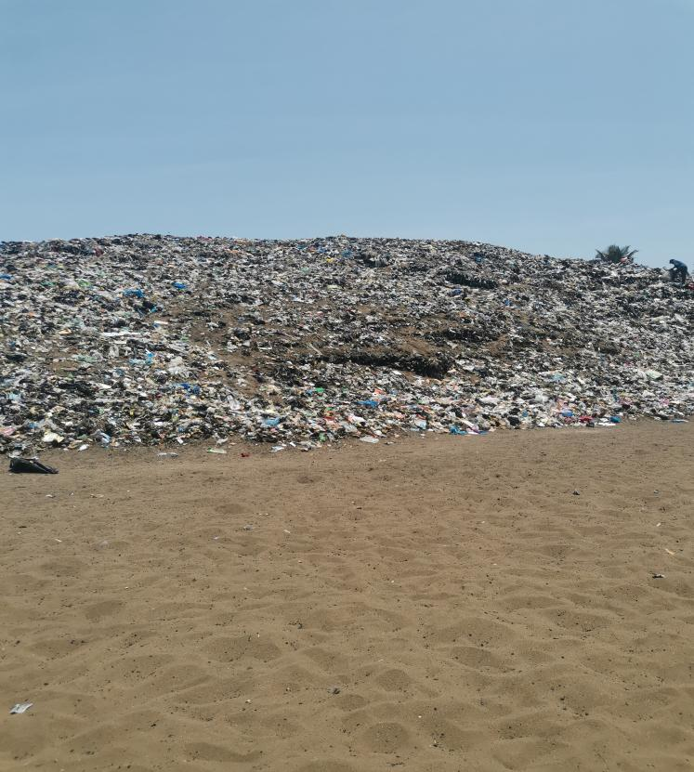
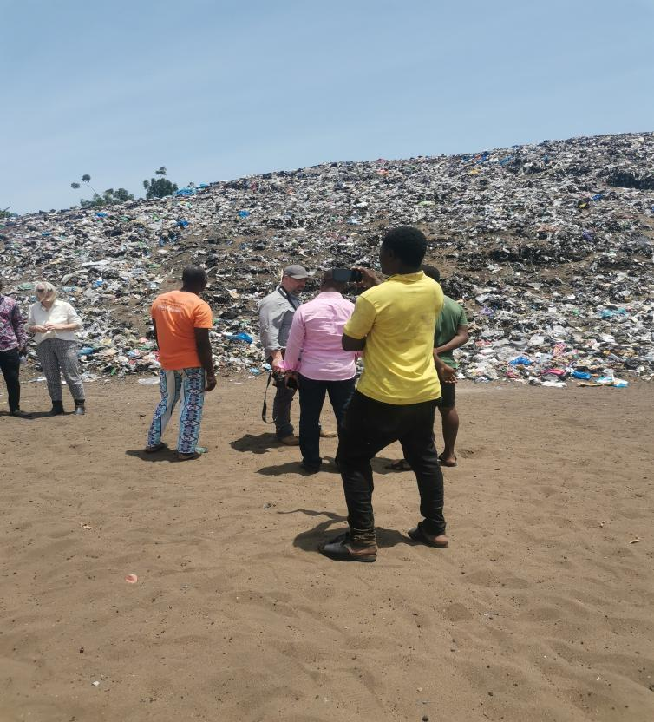

Evacuation of refuse from Dekeme illegal site to authorize final disposal site

Revenue and Expenditure Performance
This statement covers the status of the 2024 composite Budget for Ketu South Municipal Assembly (hereafter referred to as KSMA). The total amount approved for the year was GHȼ 18,424,355.55, out of which 9,405,108.82 represents 51% at the end of September under review. One of the components of this approved budget is the Internally Generated Fund (IGF) with an amount of GHȼ 2,650,000.00, out of which GHȼ 1,436,937.43 represents 54% was received at the end of the same period.
The total expenditure approved for the year, 2024, was GHȼ 18,424,355.55 out of which GHȼ 7,637,096.06, representing 41% was spent at the end of September. On the other hand, the IGF component had an approved amount of GHȼ 2,650,000.00, out of which GHȼ 1,428,280.30 represents 54% of the amount spent as of September ending.
Below are the tables of Revenue and Expenditure performance:

Revenue
Table 1: Revenue Performance – IGF Only
REVENUE PERFORMANCE – IGF ONLY
ITEMS | 2022 |  | 2023 |  | 2024 |  | % performance as at September, 2024  $$\frac{Actual}{Budget}x 100$$
ITEMS | Budget | Actuals | Budget | Actuals | Budget | Actuals as at September
Property Rates | 260,758.43 | 178,440.55 | 379,402.13 | 196,167.37 | 700,000.00 | 180,644.85 | 26%
Basic Rates | 21,000.00 | 9,000.00 | 15,000.00 | 11,285.00 | 5,000.00 | 6,980.00 | 140%
Fees | 686,343.91 | 636,521.10 | 720,742.69 | 616,592.00 | 666,700.00 | 553,288.00 | 83%
Fines | 10,670.76 | 5,885.29 | 14,892.83 | 151,508.46 | 14,700.00 | 2,359.91 | 16%
Licences | 373,758.13 | 355,923.10 | 807,862.35 | 705,191.59 | 559,500.00 | 275,091.03 | 49%
Land | 371,000.00 | 364,349.66 | 338,100.00 | 378,976.83 | 388,100.00 | 315,416.64 | 81%
Rent | 200,911.00 | 126,868.00 | 519,000.00 | 272,875.00 | 311,000.00 | 103,157.00 | 33%
Investment | 5,250.00 | 0 | 20,000.00 | 0 | 5,000.00 | - | 0%
Sub-Total | 1,929,692.23 | 1,676,987.70 | 2,815,000.00 | 2,332,596.25 | 2,650,000.00 | 1,436,937.43 | 54%
Total | 1,929,692.23 | 1,676,987.70 | 2,815,000.00 | 2,332,596.25 | 2,650,00.00 | 1,436,937.43 | 54%

Table 2: Revenue Performance – All Revenue Sources
ITEM | 2022 |  | 2023 |  | 2024
ITEM | Budget | Actual | Budget | Actual | Budget | Actual as at September | % performance as at September  𝐀𝐜𝐭𝐮𝐚𝐥 / 𝐁𝐮𝐝𝐠𝐞𝐭 𝐱 𝟏𝟎𝟎
IGF | 1,929,692.23 | 1,676,987.70 | 2,815,000.00 | 2,332,596.25 | 2,650,000.00 | 1,436,937.43 | 54%
Compensation of Employee | 2,651,908.24 | 3,341,552.40 | 4,919,847.76 | 4,774,454.41 | 5,796,355.55 | 4,560,057.27 | 79%
Goods and Services Transfer | 121,399.00 | 38,319.48 | 89,000.00 | 44,071.38 | 113,000.00 | 0 | 0%
Assets Transfer | 235,180.00 | 13,500.00 | 142,966.96 | 0 | 145,000.00 | 0 | 0%
DACF-Assembly | 4,860,964.77 | 1,709,251.90 | 5,212,615.18 | 1,215,159.73 | 5,150,000.00 | 678,888.58 | 13%
DACF-MP | 1,590,000.00 | 625,777.15 | 1,600,000.00 | 439,657.72 | 1,580,000.00 | 649,214.41 | 41%
DACF-PWD | 400,000.00 | 246,476.29 | 400,000.00 | 193,622.94 | 400,000.00 | 217,380.13 | 54%
DACF-RFG | 1,282,385.80 | 1,134,512.80 | 2,193,007.80 | 0 | 2,515,000.00 | 1,837,631.00 | 73%
DP-UNICEF | 70,0000.00 | 12,500.00 | 70,000.00 | 25,000.00 | 25,000.00 | 25,000.00 | 100%
DP-GIZ | 67,046.00 | 46,932.20 | 10,000.00 | 6,704.60 | 50,000.00 | 0 | 0%
DP-MAG | 62,778.85 | 62,778.86 | 59,020.00 | 59,098.63 | 0 | 0 | 0%
Total | 13,271,354.89 | 8,908,588.78 | 17,511,457.70 | 9,090,365.66 | 18,424,355.55 | 9,405,108.82 | 51%

Expenditure

Table 3: Expenditure Performance-All Sources
ITEM | 2022 |  | 2023 |  | 2024
ITEM | Budget | Actual | Budget | Actual | Budget | Actual as at September | % Performance as at September  $$\frac{Actual}{Budget}x 100$$
Compensation of Employees | 2,989,139.33 | 3,668,720.01 | 5,318,984.08 | 5,125,117.40 | 6,176,855.55 | 4,776,651.96 | 77%
Goods and Services | 5,379,845.73 | 3,302,457.14 | 6,265,841.37 | 2,937,652.17 | 6,612,809.00 | 2,027,859.87 | 31%
Assets | 4,902,369.83 | 1,777,981.15 | 5,926,632.25 | 1,509,478.83 | 5,634,691.00 | 832,584.23 | 15%
Total | 13,271,354.89 | 8,749,158.30 | 17,511,457.70 | 9,572,247.90 | 18,424,355.55 | 7,637,096.06 | 41%

Adopted Medium Term National Development Policy Framework (MTNDPF) Policy Objectives
- 10.2: Empower and promote the social, economic and political inclusion of all
- 17.1 Strengthen domestic resources mobilisation to improve capacity for revenue collection
- 4.1 Ensure free, equitable and quality education for all by 2030
- 6.2 Achieve access to adequate and equitable sanitation and hygiene for all
- 3.8 Achieve universal health coverage, including financial risk protection, access to quality essential health-care services
- 2.4 Ensure sustainable food production systems and implement resilient agricultural practices
- 11.3 Enhance inclusive urbanization and capacity for participatory human settlement management in all countries
- 5.1 End all Forms of discrimination against woman and girls everywhere
- 16.7 Ensure responsive, inclusive, participatory and representative decision-making at all levels
- 15.3 Combating desertification, restored degraded Land and Soil
- 9.1 Develop Quality, sustainable and resilient to support economic development and human well-being
- 6.1 Achieve universal and equitable access to safe and affordable drinking water
- 8.3 Promote developing policies that support MSMEs including access to financial services
- 8.9 Devise and implement policies to promote sustainable tourism for jobs and culture
- 1.5 Build resilient of people in a vulnerable Situation, reduce exposure to climate disasters
- 17.18 Enhance capacity building support to Developing countries to increase Data availability
- 16.6 Develop effective, accountable and transparent institutions at all levels

Policy Outcome Indicators and Targets
Table 4: Policy Outcome Indicators and Targets
Outcome Indicator | Outcome Indicator Description | Unit of Measure | Baseline (2023) |  | Current year (2024) |  | Budget year (2025) | Indicative year
 |  |  |  |  |  |  |  | 2026 | 2027 | 2028
Outcome Indicator | Outcome Indicator Description | Unit of Measure | Target | Actual | Target | Actual as at Sep. | Target | Target | Target | Target
Percentage change in IGF | The difference of current year IGF over the previous year expressed as a percentage | % | 10% | 39.1% | 10% | -19% | 10% | 10% | 10% | 10%
Completion rate at JHS | The number of pupils/students enrolled in the last grade of a given level of education (JHS 3), regardless of age, expressed as a percentage of the total population of the theoretical entrance age to the last grade of that level of education. | % | 100% | 80.7% | 100% | 100% | 100% | 100% | 100% | 100%
Maternal mortality ratio (Institutional) | Maternal deaths recorded per 100,000 live births in the district | Per 100,000 | 0 | 0 | 0 | 0 | 0 | 0 | 0 | 0
Percentage of road network in good condition | The total km of classified road network in good condition expressed as percentage of total road network | % | 80% | 57.3% | 80% | 57.3% | 80% | 85% | 90% | 100%

Revenue Mobilization Strategies
REVENUE ITEM | ACTIVITES | EXPECTED OUTPUT/ OUTCOME | IMPLEMENTATION PERIOD |  |  |  |  |  |  |  |  |  |  |  | ACTION BY | LOGISTICS REQUIRED | ESTIMATED COST GHC | FUND SOURCE
REVENUE ITEM | ACTIVITES | EXPECTED OUTPUT/ OUTCOME | J | F | M | A | M | J | J | A | S | O | N | D
Rates | Continue street naming and property addressing by the end of fourth quarter | Continue property data/Street named and property numbers fixed on properties | x | x | x | x | x | x | x | x | x | x | x | x | Street Addressing Team | Laptop / Internet connectivity / External hard disk/building permit jacket | 40,000.00 | IGF/DACF
Land and Royalties | Enforce development control laws. | Increase in building permits approved on time/compliances of building regulation | x | x | x | x | x | x | x | x | x | x | x | x | Spatial Planning Committee | Vehicle/Fuel | 15,000.00 | IGF
Licenses (BOP) | Apprehend defaulters of BOP | Payment of arrears by defaulters | x | x | x | x | x | x | x | x | x | x | x | x | MFO / Assembly Prosecutor | Vehicle/Fuel | 5,000.00 | IGF
Licenses (BOP) | Diligently mobilize funds from businesses operating in the municipality. | To meet or exceed revenue target set | x | x | x | x | x | x | x | x | x | x | x | x | Revenue Team | Vehicle / reflector / internet data / tablet | 25,000.00 | IGF
Licenses (BOP) | Supervising the zonal council in revenue collection and making sure the correct rate is collected. | To aid in an increment in the collection of revenue items | x | x | x | x | x | x | x | x | x | x | x | x | Revenue Team | Vehicle / Fuel | 15,000.00 | IGF
Fees | Institute daily market tolls | Increase in fees from market toll | x | x | x | x | x | x | x | x | x | x | x | x | Budget Committee | Value Book/Running cost/Stationery | 10,000.00 | IGF
Fees | Effective and efficient means to prevent nonpayment of revenue. | To formed well motivated taskforce to ensure collection of revenue |  |  |  |  |  |  | x | x | x | x | x | x | Task force | ID card / Van / Reflector | 10,000.00 | IGF
Fines, Penalties and Forfeits | Enforcing the Assembly bye laws. | Compliance to Bye Laws without default | x | x | x | x | x | x | x | x | x | x | x | x | MEHO / MFO | Vehicle / Uniform / Raincoat / Wellington Boot / ID card | 5,000.00 | IGF
Rent | Ensure periodic rent collection of market store/stalls and bungalows | Achieve 80% of rent in arrears and current rent | x | x | x | x | x | x | x | x | x | x | x | x | Revenue Supt. | Value Book / Stationery | 5,000.00 | IGF
Investment Income | Start operations and aid revenue mobilization | For the tipper truck to be put to productive use to generate revenue | x | x | x | x | x | x |  |  |  |  |  |  | MCD | Tyres / Battery/Back Axle | 50,000.00 | IGF
Total |  |  |  |  |  |  |  |  |  |  |  |  |  |  |  |  | 180,000.00

PART B: BUDGET PROGRAMME/SUB-PROGRAMME SUMMARY

PROGRAMME 1: MANAGEMENT AND ADMINISTRATION
Budget Programme Objectives
- Empower and promote the social, economic and political inclusion of all
- Strengthen domestic resources mobilisation to improve capacity for revenue collection
- Enhance capacity building support to developing countries to increase Data availability

Budget Programme Description
This programme seeks to perform the core functions of ensuring good governance and a balanced developmental level for the Municipality through the formulation and implementation of policies, planning, management of human resources, coordination and application of statistics as well an efficient monitoring and evaluation process in the area of local governance.

The programme is being implemented and delivered in collaboration with the offices of the Central (General) Administration, Human Resource Department, Statistics Department and Finance Department. The units that deliver this programme include the Central Administration Unit, the Budget Unit, the Account Department, the Procurement Unit, the Planning Unit and the Records Management Unit. The amount allocated for the year to round this budget was GHȼ 7,663,139.00, but has now been revised to GHȼ 9,950,890.00

The total staff strength that delivers this programme is One Hundred and thirteen, which includes Administrators, Budget Analysts, Accountants, Planning Officers, Revenue Officers/Collectors, Statisticians, Human Resource Managers and other supporting staff such as Watchmen/Security personnel, Finance clerks, Cleaners and Drivers, amongst other positions or designations. The programme is being funded through the Assembly’s Composite Budget with Internally Generated Fund (IGF) and Government of Ghana transfers (District Assembly Common Fund and DACF Responsive Factor Grant (DACF-RFG) and support from Donor Partners.

SUB-PROGRAMME 1.1 General Administration
Budget Sub-Programme Objective
- Empower and promote the social, economic and political inclusion of all

Budget Sub-Programme Description
The General Administration sub-programme looks at the provision of administrative support and effective coordination of the activities of the various departments through the Office of the Municipal Co-ordinating Director. The sub-programme is responsible for all the activities and programmes relating to general services, internal controls, procurement/stores, transport, public relations and security. The total amount budgeted to cater for this sub-programme was GHȼ 7,021,139.00 for the year and is now revised to GHȼ 9,103,390.00.

The core function of the General Administration Unit is to facilitate the Assembly’s activities with the various departments, quasi-institutions, and traditional authorities, also mandated to carry out regular maintenance of the Assembly’s properties. In addition to its responsibilities is to constitute the Municipal Security Committee (MUSEC) is mandated to initiate and implement programmes and strategies to improve the security situation in the Municipality.

The Procurement and the Stores Units are responsible for the procurement processes of Goods and Services as well as Assets for Assembly. These Units also have the duty of ensuring that inventory and store management are undertaken properly. The Records Management Unit is also responsible for ensuring that records are properly documented.

The number of staff that deliver this sub-programme is Forty-three (43) GoG Staff as well as Nine (9) IGF Staff and is funded by the Assembly’s Internally Generated Fund (IGF), District Assembly Common Fund (DACF), District Assembly Common Fund Responsive Factor Grant (DACF-RFG) and Government of Ghana (GOG) transfers. The following benefit from this sub-programme; the various decentralised and non-decentralised departments in the Municipal Assembly, quasi-institutions, traditional authorities, Non-Governmental Organisations (NGOs), Civil Society Organisations (CSOs) and the general public.
The main challenges this sub-programme will be facing include inadequate, delayed and untimely release of funds and non-decentralization of some key departments as well as inadequate logistics such as lack of office space for some departments and units (inadequate internet infrastructure leading to slow and poor internet connectivity which leads to delay in work activities).

Table 5: Budget Sub-Programme Results Statement
Main Outputs | Output Indicators | Past Years |  | Projections
 |  | 2023 | 2024 as of September | 2025 | 2026 | 2027 | 2028
General Assembly meeting organised | Number of meetings held | 3 | 1 | 3 | 3 | 3 | 3
Organise quarterly management meetings annually | Number of quarterly meetings held | 4 | 2 | 3 | 3 | 3 | 3
Enhance service delivery | No. of reports prepared and submitted | 5 | 3 | 5 | 5 | 5 | 5
Response to public complaints | Number of working days after receipt of complaints | 4 | 2 | 4 | 4 | 4 | 4
Compliance with procurement procedures | Number of Entity Tender Committee meetings | 4 | 2 | 4 | 4 | 4 | 4

Budget Sub-Programme Standardized Operations and Projects

Table 6 lists the standardized operations and the standardized projects that will be undertaken by this sub-programme.

Table 6: Budget Sub-Programme Standardized Operations and Projects
Standardized Operations | Standardized Projects
Internal Management of The Organisation (Printed materials, Refreshment items, Electrical accessories, Uniform and protective clothing, Electrical charges, water, Fuel and lubricants, Running costs, Other Travel and Transport, Local travel cost, Seminars/Conferences/Workshops – Domestic, etc)
Procurement Of Office Supplies and Consumables
Information, Education and Communication
Procurement Of Office Equipment and Logistics
Gender related activities
Monitoring And Evaluation of Programmes and Projects
Protocol Services
Administrative And Technical Meetings
Procurement Management
Security Management
Support to traditional authorities
Citizen Participation in Local Governance
Legal services

SUB-PROGRAMME 1.2 Finance and Audit
Budget Sub-Programme Objective
• Strengthen domestic resource mobilization

Budget Sub- Programme Description
This sub-programme provides effective and efficient management of financial resources and timely reporting of the Assembly’s financial report as stipulated in the Public Financial Management Act 2016 (Act, 921) and it’s associated as well as related regulations. It also ensures that financial transactions and controls are consistent with prevailing financial and accounting policies, rules, regulations and best practices.

The sub-programme operations and major services delivered include; undertaking revenue mobilizations activities of the Assembly; keeping, rendering and publishing statements on public accounts; keeping receipt and custody of all public and trust monies payable into the Assembly’s accounts, and facilitating the disbursement of legitimate and authorize payments or transactions.
The Internal Audit Unit is mandated to implement various internal audit control procedures and processes to manage and control audit risks and detection and prevention of misstatement of facts that could result in unnecessary wastage, fraud and abuse of the Assembly. The amount assigned to run this sub-programme was GHȼ 276,000.00 and now been reviewed to GHȼ 381,500.00.

The sub-programme is manned by Nineteen (19) officers consisting of Accountants, Finance Clerks, Revenue Collectors and Internal Audit Officers with funding from DACF and Internally Generated Fund (IGF). The general public, allied institutions, and the various departments and units are the beneficiaries of this sub-programme.

The challenges faced by this sub-programme include untimely release of funds, inadequate logistics for revenue mobilisation and delay in response to audit observation from auditees.

Table 7: Budget Sub-Programme Results Statement

Table 7 below indicates the main outputs, its indicators and projections on which the Municipal Assembly measures its performance in relation to this sub-programme. It shows the past performance of the Assembly in 2023 and as of September 2024 as well as future estimated targets.

Main Outputs | Output Indicators | Past Years |  | Projections
 |  | 2023 | 2024 as at Sept. | 2025 | 2026 | 2027 | 2028
Audit queries | Timely response to audit queries | Within 10 working days | Within 10 working days | Within 10 working days | Within 10 working days | Within 10 working days | Within 10 working days
Audit queries | Number of issues addressed in the audit query by management | 20 | 11 | 10 | 8 | 6 | 4
Internal Audit report | Number of audit assignments conducted with a report | 4 | 3 | 4 | 4 | 4 | 4
Financial statements | Annual statement of accounts submitted | 1 | 0 | 1 | 1 | 1 | 1
Financial statements | Number of the monthly financial reports submitted | 12 | 9 | 12 | 12 | 12 | 12

Budget Sub-Programme Standardized Operations and Projects
Table 8 lists the standardized operations and the standardized projects that will be undertaken by this sub-programme.

Table 8: Budget Sub-Programme Standardized Operations and Projects
Standardized Operations | Standardized Projects
Internal management of the organization (other travel and transportation)
Procurement of office equipment and logistics
Treasury and accounting activities
Internal Audit operations
Revenue collection and management

SUB-PROGRAMME 1.3 Human Resource Management

Budget Sub-Programme Objective
- Develop effective, accountable and transparent institutions at all levels

Budget Sub-Programme Description
The Human Resource Management Department seeks to build the capacity of the manpower or staff, which will in the short run lead to an improvement in the timely decision-making of the departments/units and divisions and subsequently lead to an improved and effective organization. In carrying out its duties, this sub-programme is expected to enhance the productivity of the Assembly and the decision-making of the Human Resource Department.

Some of the operations and activities undertaken by this sub-programme include human resource audit, performance management, service delivery improvement, upgrading and promotion of staff. It also includes the Human Resource Management Information System (HRMIS) which ensures that staff records are updated frequently through the adoption of an electronic system. Other benefits of the use of the HRIMS include efficient and proper salary administration, facilitation of recruitment, selection and posting of competent staff to fill available vacancies at the Zonal council in the Municipality.

Under this sub-programme, three (3) staff carries out its implementation with funding from GoG transfers, Internally Generated Fund (IGF), DACF-RFG and DACF. The challenges that this sub-programme faces include inadequate logistics and delays in fund releases towards the implementation of capacity-building plans

The following benefit from the operations and activities of this sub-programme; staff of the various Departments and Units and the general public. Also, the total amount allocated for this sub-programme is GHȼ 225,000.00 but now been reviewed to GHȼ 285,000.00.

Budget Sub-Programme Results Statement

Table 1 below indicates the main outputs, its indicators and projections which the Municipal Assembly measures its performance in relation to this sub-programme. It shows the past performance of the Assembly in 2023 and as of September 2024 as well as future estimated targets.

Table 9: Budget Sub-Programme Results Statement
Main Outputs | Output Indicators | Past Years |  | Projections
 |  | 2023 | 2024 as at September | 2025 | 2026 | 2027 | 2028
Human resource Management improved | No. of staff appraised | 114 | 110 | 120 | 125 | 130 | 135
Human resource Management improved | No. of staff development workshops | 4 | 3 | 4 | 4 | 4 | 4
Human resource Management improved | No. of Staff validated monthly | 12 | 9 | 12 | 12 | 12 | 12

Budget Sub-Programme Standardized Operations and Projects

Table 10 lists the standardized operations and the standardized projects that will be undertaken by this sub-programme

Table 10: Budget Sub-Programme Standardized Operations and Projects
Standardized Operations | Standardized Projects
Internal Management of The Organisation (refund of medical expenses, Seminars/Conferences/Workshops – Domestic and Transportation)
Procurement of office equipment and logistics
Personnel and Staff Management
Performance management
Staff Training and skills development

SUB-PROGRAMME 1.4 Planning, Coordination and Statistics

Budget Sub-Programme Objective
- Enhance capacity building support to Developing countries to increase Data availability

Budget Sub- Programme Description
The sub-programme coordinates policy formulation, preparation and implementation of the Assembly’s Medium Term Development Plan, Annual Action Plan, and Annual Composite Budget. The main units under this sub-programme include the Development Planning Unit, the Budget Unit and the Statistics Department. The main sub-operation include;

- Prepare and review the Medium-Term Development Plan, Annual Action Plans and Annual Composite Budget.
- Ensure that the Annual Action Plan and the Annual Composite Budget are approved by the General Assembly
- Ensure that each project or programme that the Assembly wants to embark on has a budgetary allocation in the GIFMIS software in accordance with their mandates.
- Co-ordinate all projects and programmes stipulated in the Annual Action Plan
- Monitor and evaluate all projects and programmes stipulated in the Annual Action Plan to ensure compliance with rules, value for money and enhance performance
- Organise stakeholders’ meetings, public fora and town hall meetings
- Co-ordinate and harmonise all data collection activities
- Dissemination of Government statistics information

There are Ten (10) staff who are responsible for the delivery of this sub-programme and are made up of Five (5) staff in the Budget Unit, 3 staff in the Development Planning Unit and Two (2) staff in the Statistics Department. The main funding source of this sub-programme is GoG transfer, DACF and the Assembly’s Internally Generated Fund. Beneficiaries of this sub-programme are the departments and units in the Assembly, allied institutions and the general public.

Challenges faced by this sub-programme are untimely submission of departmental reports, inadequate logistics to undertake effective research, data collection and data management and untimely release of funds, leading to ineffective and/or delayed monitoring and evaluation. The total budgeted for this program was GHȼ 141,000.00 now been reviewed to GHȼ 181,000.00.

Budget Sub-Programme Results Statement
Table 11 below indicates the main outputs, its indicators and projections which the Municipal Assembly measures its performance in relation to this sub-programme. It shows the past performance of the Assembly in 2023 and as of September 2024 as well as future estimated targets.

Table 11: Budget Sub-Programme Results Statement
Main Outputs | Output Indicators | Past Years |  | Projections
 |  | 2022 | 2024 as at September | 2025 | 2026 | 2027 | 2028
Timely approval of Plans and Budget | AAP and Annual Composite Budget approved by the General Assembly | 28th October,2022 | Yet to approve | 30th October | 30th October | 30th October | 30th October
Enhanced Transparent and Accountable governance | No. of Town hall meetings | 2 | 0 | 2 | 2 | 2 | 2
Enhanced Transparent and Accountable governance | Percentage of communities visited by the MCE | 30% | 0% | 30% | 30% | 30% | 30%
Enhanced Transparent and Accountable governance | No. of quarterly performance report | 4 | 3 | 4 | 4 | 4 | 4
Enhanced Transparent and Accountable governance | No. of quarterly progress report | 4 | 3 | 4 | 4 | 4 | 4
Enhanced Transparent and Accountable governance | No. of quarterly statistics departmental report | 4 | 3 | 4 | 4 | 4 | 4

Budget Sub-Programme Standardized Operations and Projects

Table 12 lists the standardized operations and the standardized projects that will be undertaken by this sub-programme.

Table 12: Budget Sub-Programme Standardized Operations and Projects
Standardized Operations | Standardized Projects
Internal Management of The Organisation (Other Travel and Transportation, Seminars/Conferences/Workshops – Domestic, Local Travel)
Procurement of office equipment and logistics
Data And Information Dissemination
Coordination And Harmonization of Data
Plan And Budget Preparation
Training on method and Statistical concept

SUB-PROGRAMME 1.5 Legislative Oversights

Budget Sub-Programme Objective
- Empower and promote the social, economic and political inclusion of all

Budget Sub- Programme Description
This sub-programme formulates appropriate specific municipal policies and implements them in the context of national policies. These policies are deliberated upon by its Zonal Councils, Sub-Committees and Executive Committee. The report of the Executive Committee is eventually considered, approved and passed by the General Assembly into lawful municipal policies and objectives for the growth and development of the municipality.

The office of the Honourable Presiding Member spearheads the work of the Legislative Oversight role and is ably assisted by the Office of the Municipal Coordinating Director. The units under this sub-programme include the Zonal Councils, and the Office of the Presiding Member and other statutory sub-committees such as the Finance and Administration Sub-Committee, Development Planning Sub-committee, Social Audit Committee amongst other sub-committee.

There are five (5) Zonal Councils in KSMA; namely, Aflao- Wego, Somey-Wego, Somey-Fugo, Klikor and Aflao Zonal Councils. Additionally, there are fifty-seven (57) assembly members in Ketu South Municipal Assembly.

The activities of this sub-programme are financed by the Assembly’s IGF and DACF.

The beneficiaries of this sub-programme are the local communities and the general public.

The challenges faced by this sub-programme include untimely release of funds, logistical constraints such as Laptops, printers and photocopiers, and lack of capacity- building for assembly members.

Budget Sub-Programme Results Statement
Table 13 below indicates the main outputs, its indicators and projections which the Municipal Assembly measures its performance in relation to this sub-programme. It shows the past performance of the Assembly in 2023 and as of September 2024 as well as future estimated targets.

Table 13: Budget Sub-Programme Results Statement
Main Outputs | Output Indicators | Past Years |  | Projections
Main Outputs | Output Indicators | 2023 | 2024 as at September | 2025 | 2026 | 2027 | 2028
Enhanced Transparent and Accountable governance | No. of General Assembly held | 3 | 2 | 3 | 3 | 3 | 3
Enhanced Transparent and Accountable governance | No. of statutory meetings held | 3 | 2 | 3 | 3 | 3 | 3

Budget Sub-Programme Standardized Operations and Projects
Table 14 lists the standardized operations and the standardized projects that will be undertaken by this sub-programme.

Table 14: Budget Sub-Programme Standardized Operations and Projects
Standardized Operations | Standardized Projects
General Assembly
Support for sub-Committees meetings, e.g., Social Audit Committee
PRCC meetings
Monitoring and evaluation

PROGRAMME 2: SOCIAL SERVICES DELIVERY
Budget Programme Objectives
- Ensure free, equitable and quality education for all by 2030
- Achieve universal health coverage, including financial risk protection, access to quality essential health-care services
- Achieve access to adequate and equitable sanitation and hygiene for all

Budget Programme Description
The Social Service Delivery programme seeks to harmonise the activities and functions of the following services, agencies, departments and units in the municipality; the Ghana Education Service (GES), Youth Employment Agency (YEA), the Environmental Health Unit, Social Welfare and Community Development, the Municipal Birth and Death Registry.
The Education, Youth and Sports sub-programme is responsible for pre-schools, special schools, basic education, youth and sports development as well as library services at the Municipal level.
The Public Health Services and Management aims to provide facilities, infrastructural services and programmes for the effective and efficient promotion of public health in the Municipality.
The Social Welfare and Community Development department is responsible for this particular sub-programme. It basically, seeks to promote and protect the rights of children and the vulnerable, seek justice and administration of child-related issues and provide community care for the disabled and needy adults.
The Birth and Death Registration Services seeks to provide accurate, reliable and timely information on all births and deaths occurring within the Municipality for socio-economic development.
The funding sources for the programme include GoG transfers, DACF, DACF-RFG, Donor Fund and Assembly’s Internally Generated Fund. The general public is the main beneficiary of this programme and the amount allocated for the programme is GHȼ 3,039,485.00 but have now been revised to GHȼ 19,044,261.00

SUB-PROGRAMME 2.1 Education, Youth and Sports Services

Budget Sub-Programme Objective
- Ensure free, equitable and quality education for all by 2030

Budget Sub- Programme Description
The Education, Youth and Sports sub-programme is responsible for pre-schools, special schools, basic education, youth and sports development as well as library services at the Municipal level. Some vital sub-operations under this sub-programme include:
• Giving advice to the Municipal Assembly on matters relating to the schools at all levels in the municipality and on any other matter that may be referred.
• Facilitating the supervision of pre-school, primary schools, Junior High Schools, Senior High Schools.
• Coordinating the organization and supervision of training programmes for youth in the district to develop leadership qualities, personal initiatives, patriotism and community spirit
• Giving advice on all matters relating to sports development in the Municipality
• Giving advice on the provision and management of public libraries and library service in the municipality in consultation with the Ghana Library Board.
Organisational units that who deliver this sub-programme include the Ghana Education Service (GES), District Youth Authority, Youth Employment Agency (YEA) and Non-Formal Department with funding from Assembly’s Internally Generated Fund (IGF), DACF and DACF-RFG (DPAT). The amount allocated for this sub-programme is GHȼ1,195,000.00 and the amount has been revised to GHȼ 9,106,695.00.
The challenges that this sub-programme untimely release of funds and insufficient bungalows for teachers.

Budget Sub-Programme Results Statement

Table 15 below indicates the main outputs, its indicators and projections which the Municipal Assembly measures its performance in relation to this sub-programme. It shows the past performance of the Assembly in 2023 and as of September 2024 as well as future estimated targets.

Table 15: Budget Sub-Programme Results Statement
Main Outputs | Output Indicators | Past Years |  | Projections
 |  | 2023 | 2024 as at September | 2025 | 2026 | 2027 | 2028
Access to education improved | No. of classroom blocks constructed | 1 | 0 | 1 | 1 | 1 | 1
STMIE clinics organised | No. of clinics organised | 1 | 1 | 2 | 2 | 2 | 2

Budget Sub-Programme Standardized Operations and Projects

Table 16 lists the standardized operations and the standardized projects that will be undertaken by this sub-programme.

Table 16: Budget Sub-Programme Standardized Operations and Projects
Standardized Operations | Standardized Projects
Gender Related Activities | Procurement of furniture for various schools
Official / National Celebrations | Construction of 1No. 2-unit early childhood block at Aflao-Agblekpui
Development of youth, sports and culture | Construction of 1No. 6uniit Classroom block at Avoeme (Phase two)
Support to teaching and learning delivery (Schools and Teachers award scheme, educational financial support | Additional work on the canteen Shed at Aflao Senior High School
Acquisition Of Movable and Immovable Assets | Construction of 1No. 3-unit JHS block with WC, changing room, furniture, staff common room, local borehole, library/ICT room at Aflao-Agblekpui
Maintenance, Rehabilitation, refurbishment and upgrading of existing assets | Construction of 1No. 2-unit KG Block with WC, changing room, furniture, staff common room, local borehole, water harvest and storage system, library/ICT room and 1No. A self-contained bedroom bungalow for the head teacher at Akaglakope
 | Construction of 1No. 6-unit Primary Block with WC, changing room, furniture, staff common room, local borehole, water harvest and storage system, library/ICT room and 1No. Bedroom self-contained bungalow for the head teacher at Akaglakope
 | Construction of 1No. 2-unit KG Block with WC, changing room, furniture, staff common room, local borehole, water harvest and storage system at Glidzi
 | Completion of 1No. 3-unit Classroom Block with ancillary facilities at Adafienu EP Basic School
 | Completion of 1No. 2-unit early childhood block at Akporkploe

SUB-PROGRAMME 2.2 Public Health Services and Management
Budget Sub-Programme Objective
- Achieve universal health coverage, including financial risk protection, access to quality essential health-care services

Budget Sub-Programme Description
The sub-programme aims at providing facilities, infrastructural services and programmes for the effective and efficient promotion of public health in the Municipality. Public Health aims at providing and delivering public, family and child health services directed at preventing diseases and promoting the health of all people living in the Municipality. It also seeks to coordinate the works of health centres or posts or community-based health workers and facilitates the collection and analysis of data on health. In addition, emphasis will be placed on supporting high-risk groups to prevent the spread of HIV/AIDS, TB and Malaria among others.
The sub-programme includes;
• Advising the assembly on all matters relating to health including diseases control and prevention
• Implement an emergency epidemic preparedness plan
• Undertaking health education and family immunization and nutrition programmes
• Preventing new transmission, including awareness creation, direct services delivery and supporting high-risk groups.
• Providing support to people living with HIV/AIDS (PLWHA) and their families
The sub-programme would be delivered through the offices of the Municipal Health Directorate and the following are the sources of funds for this sub-programme; GoG transfers, DACF, Assembly’s Internally Generated Fund (IGF) and Donor Support. The various health facilities and the entire citizenry in the municipality are the beneficiaries of this sub-programme. The Staff strength of approximately 160, and the total amount allocated for this sub-programme is GHȼ 75,000.00 and the amount has been reviewed to GHȼ 4,904,983.00.

The challenges are untimely release of funds and insufficient bungalows for health practitioners.

Budget Sub-Programme Results Statement
Table 17 below indicates the main outputs, indicators and projections on which the Municipal Assembly measures its performance in relation to this sub-programme. It shows the past performance of the Assembly in 2023 and as of September, 2024 as well as future estimated targets.

Table 17: Budget Sub-Programme Results Statement
Main Outputs | Output Indicators | Past Years |  | Projections
 |  | 2023 | 2024 as at September | 2025 | 2026 | 2027 | 2028
Access to health service delivery improved | No. of functional health facilities constructed | 1 | 0 | 2 | 2 | 2 | 2
Access to health service delivery improved | No. of HIV stakeholders meeting conducted | 4 | 3 | 4 | 4 | 4 | 4

Budget Sub-Programme Standardized Operations and Projects
Table 18 lists the standardized operations and the standardized projects that will be undertaken by this sub-programme

Table 18: Budget Sub-Programme Standardized Operations and Projects
Standardized Operations | Standardized Projects
Covid-19 Related reliefs | Construction of 1No. CHPS compound with semi-detached chamber and hall, self-contained nurses' quarters, local borehole with water harvest system, lying-in ward and furniture for wards at Dodorkope
Public Health services support | Construction of 1No. CHPS compound with semi-detached chamber and hall self-contained nurses’ quarters, local borehole with water harvest system and furniture for wards at Dogbekope
District response initiative (DRI) on HIV/AIDS and Malaria | Construction of 1No.semi-detached chamber and hall self-contained nurses’ quarters, local borehole with water harvest system and furniture for wards at Nogokpo
Maintenance, Rehabilitation, refurbishment and upgrading of existing assets | Completion of 1No. CHPS compound with a 2-bedroom semi-detached bungalow Atoklokope
Acquisition Of Movable and Immovable Assets | Completion of CHPS compound and nurse’s bungalow at Zuime
 | Completion of 1No. CHPS compound (with bedroom semi-detached) at Glidzi
 | Completion and renovation work of the CHPS compound with the Maternity block and nurses' quarters at Klikor Shitokope

SUB-PROGRAMME 2.3 Social Welfare and Community Development
Budget Sub-Programme Objective
- End all Forms of discrimination against women and girls everywhere
- Ensure responsive, inclusive, participatory and representative decision-making at all levels

Budget Sub-Programme Description
The Social Welfare and Community Development department is responsible for this particular sub-programme. It basically seeks to promote and protect the rights of children and the vulnerable, seek justice and administration of child-related issues and provide community care for disabled and needy adults.

On the other hand, Community Development is also tasked with the responsibility of promoting social and economic growth in rural communities through popular participation and initiatives of community members in activities of poverty alleviation, employment creation and illiteracy eradication amongst the adult and young adult populace in both the rural and urban poor areas in the Municipality. Major services to be delivered include;
• Facilitating community-based rehabilitation of persons with disabilities
• Assisting and facilitating the provision of community care services, including registration of persons with disabilities, assistance to the aged, personal social welfare services, providing assistance to street children, child survival and development, and socio-economic and emotional stability in families.
• Assisting in organising community development programmes to improve and enrich rural life through literacy and adult education classes, voluntary contribution and communal labour to provide facilities and services such as water, schools, library, community centres and public places of convenience.

The Social Welfare and Community Development sub-programme is manned by five (5) staff members and funded with GoG transfers, DACF, DACF-RFG, Donor support (UNICEF) and the Assembly’s IGF. The amount assigned to run it is GHȼ1,243,485.00 and now revised to GHȼ 2,440,485.00
The challenges these sub-programmes faced include the unavailability of logistics, especially a vehicle to facilitate the mobility of officers to undertake their duties efficiently and effectively and the untimely release of funds.

Budget Sub-Programme Results Statement
Table 19 below indicates the main outputs, indicators and projections on which the Municipal Assembly measures its performance in relation to this sub-programme. It shows the past performance of the Assembly in 2023 and September 2024 as well as future estimated targets.

Table 19: Budget Sub-Programme Results Statement
Main Outputs | Output Indicators | Past Years |  | Projections
Main Outputs | Output Indicators | 2023 | 2024 as at September | 2025 | 2026 | 2027 | 2028
Improved Social Welfare and Protection services | No. of people who benefited (medical support) | 63 | 62 | 90 | 90 | 100 | 110
Improved Social Welfare and Protection services | No. of recorded cases of child violence benefitting from supported Social Welfare services | 137 | 0 | 400 | 450 | 500 | 550
Improved Social Welfare and Protection services | No. of children reached by Social Welfare services | 2,241 | 47 | 10,430 | 10,550 | 10,650 | 10,800
Improved Social Welfare and Protection services | No. of LEAP household members on NHIS | 13,024 | 356 | 34,997 | 40,000 | 40,200 | 40,500
Improved Social Welfare and Protection services | No. of girls reached by prevention and care services | 1,500 | 24 | 1,650 | 1,750 | 1,800 | 1,850

Budget Sub-Programme Standardized Operations and Projects
Table 20 lists the standardized operations and the standardized projects that will be undertaken by this sub-programme.

Table 20: Budget Sub-Programme Standardized Operations and Projects
Standardized Operations | Standardized Projects
Internal Management of The Organisation (Seminars/Conferences/Workshops – Domestic, Office Facilities, Supplies and Accessories) | Construction and completion as well as furnishing of the juvenile/shelter home for vulnerable
Information, education and communication | Purchase of training tools for the Skills Development Training projects
Procurement Of Office Equipment and Logistics | Construction of a wall for the juvenile shelter home at Tokor
Social intervention programmes
Gender empowerment and mainstreaming
Community mobilization
Child rights promotion and protection
PWD related activities
Acquisition Of Movable and Immovable Assets

SUB-PROGRAMME 2.4 Birth and Death Registration Services
Budget Sub-Programme Objective
- Enhance capacity building support to Developing countries to increase Data availability

Budget Sub- Programme Description
This sub-programme seeks to provide accurate, reliable and timely information on all births and deaths occurring within the Municipality for socio-economic development through their registration and certification. The operation of the Birth and Death Registration Services sub-programme includes;
• Legalisation of registration of births and deaths.
• Storage and management of the birth and death register or records.
• Issuance of certified copies of entries in the registers of births and deaths upon request.
• Preparation of documents for exportation of the remains of deceased persons
• Verification and authentication of births and deaths certificated for institutions
• Processing of documents for the exhumation and reburial of the remains of persons already buried.

Staff of the Municipality Birth and Death Registry, who are two (2) and 2 other supporting staff in number deliver this sub-programme in the municipality. They are financially supported by GoG transfers, and the beneficiaries are the entire populace in the Municipality. The Birth and Death Registration Services sub-programme is faced with the following challenges: small office space and untimely release of funds, and the total amount assigned for running this sub-programme is GHȼ 20,000.00 and has now been revised to GHȼ30,000.00.

Budget Sub-Programme Results Statement
Table 21 below indicates the main outputs, its indicators and projections on which the Municipal Assembly measures its performance in relation to this sub-programme. It shows the past performance of the Assembly in 2023 and as of September 2024, as well as future estimated targets

Table 21: Budget Sub-Programme Results Statement
Main Outputs | Output Indicators | Past Years |  | Projections
 |  | 2023 | 2024 as at September | 2025 | 2026 | 2027 | 2028
Improved biostatistical records | Lives birth in all places (10-50+) | 4,472 | Data yet to be collated | 5,000 | 7,000 | 9,000 | 11,000
Improved biostatistical records | Death in all places | 1,314 | Data yet to be collated | 2,000 | 3,000 | 4,000 | 7,000

Budget Sub-Programme Standardized Operations and Projects
Table 22 lists the standardized operations and the standardized projects that will be undertaken by this sub-programme.

Table 22: Budget Sub-Programme Standardized Operations and Projects
Standardized Operations | Standardized Projects
Information, education and communication
Data collection

SUB-PROGRAMME 2.5 Environmental Health and Sanitation Services
Budget Sub-Programme Objective
- Achieve access to adequate and equitable sanitation and hygiene for all

Budget Sub- Programme Description
The sub-programme aims at providing facilities, infrastructural services and programmes for the effective and efficient promotion of environmental health in the Municipality. Environmental Health and Sanitation Services sub-programme aim at providing and delivering improved environmental sanitation and environmental health services directed at preventing diseases and promoting the health of all people living in the Municipality. It also seeks to provide, supervise and monitor the execution of environmental health and environmental sanitation services which eventually will lead to the empowerment of individuals and communities to analyse their sanitation situations. The sub-programme includes;
• Conducting random inspections of meat, fish, vegetables and other foodstuffs as well as liquids of whatever kind or nature, whether intended for sale or not and to seize, destroy and otherwise deal with such liquids or foodstuff as are unfit for human consumption
• Undertake supervisory roles and take control of slaughterhouses and animal pounds and all such matters and things as may be necessary for the convenient use of such slaughterhouses and animal pounds.
• Taking up advisory roles on especially the rearing or keeping of animals such as sheep, goats, cows, hens etc in the municipality.
The sub-programme would be delivered through the offices of the Municipal Health Directorate and the Environmental Health Unit with a total strength of Twenty-Two (22) GoG staff and Five (5) IGF. These are the sources of funds for this sub-programme; GoG transfers, DACF, Assembly’s Internally Generated Fund (IGF) and Donor Support. The entire citizenry in the municipality is the beneficiary of this sub-programme.
The challenges faced by this sub-programme include insufficient personnel to undertake its operations and activities as well as lack of logistics (refuse containers), Vehicle for mobility, untimely release of funds, pile up refuse at Aflao beat 6 (Dekeme), lack of stray animal pens, abandonment of slaughter house at Denu and finally lack of water and electricity at Aflao slaughter house and amount also allocated to take care this programme is GHȼ506,000.00 and the amount during the mid-year increased to GHȼ2,562,098.00.

Budget Sub-Programme Results Statement
Table 24 below indicates the main outputs, its indicators and projections on which the Municipal Assembly measures its performance in relation to this sub-programme. It shows the past performance of the Assembly in 2023 and as of September 2024 as well as future estimated targets

Table 23: Budget Sub-Programme Results Statement
Main Outputs | Output Indicators | Past Years |  | Projections
 |  | 2023 | 2024 as at September | 2025 | 2026 | 2027 | 2028
Improved food Hygiene and sanitation | No. of vendors screened annually | 4,000 | 2,567 | 4,010 | 4,360 | 4,750 | 5,000
Improved food Hygiene and sanitation | Percentage of households with improved sanitation | 26 | 19.4 | 35.8 | 52.2 | 55 | 60

Budget Sub-Programme Standardized Operations and Projects
Table 24 lists the standardized operations and the standardized projects that will be undertaken by this sub-programme.

Table 24: Budget Sub-Programme Standardized Operations and Projects
Standardized Operations | Standardized Projects
Internal management (uniform and protective clothing) | Procurement and installation of 13 large solid waste skip metal containers for the Communities and Schools
COVID-19 Sanitation-related expenditures | Procurement of logistics (2No. motor bikes), sanitary tools for sanitation day, material for burial of paupers and routine cleaning/cleansing
Environmental Sanitation Management | Evacuation of 5No. unauthorised dumping sites
Solid waste management | Opening of the road to the liquid waste disposal site
Liquid waste management | Engineering of a liquid waste disposal site
Acquisition Of Movable and Immovable Assets | Carry out a municipal-wide disinfection exercise (Fumigation)

PROGRAMME 3: INFRASTRUCTURE DELIVERY AND MANAGEMENT
Budget Programme Objectives
- Develop Quality, sustainable and resilient to support economic development and human well-being
- Achieve universal and equitable access to safe and affordable drinking water

Budget Programme Description
The Physical Planning and Works Department is responsible for the operations under this programme. The Physical and Spatial Planning Development seeks to advice the Municipal Assembly on national policies on physical planning, land use and development. It basically focuses on human settlement development and ensuring that human activities within the municipality are undertaken in a more planned, orderly and spatially organised manner.

The Department of Works of the Municipal Assembly is a merger of the former Public Works Department, Department of Feeder Roads and Water and Sanitation Unit within the framework of national policies.

This programme has a total number of strengths standing at fourteen (14)

The programme is implemented with funding from GoG transfers, DACF and Internally Generated Fund (IGF) from the Assembly. The beneficiaries of the programme include rural and urban dwellers in the Municipality. The amount set to run this programme is GHȼ 2,557,146.00, and later in the year, revised to GHȼ 11,680,649.00.

SUB-PROGRAMME 3.1 Physical and Spatial Planning Development
Budget Sub-Programme Objective
- Enhance inclusive urbanization and capacity for participatory human settlement management in all countries

Budget Sub- Programme Description
The sub-programme seeks to coordinate activities and projects of departments and other agencies including Non-Governmental Organizations (NGOs) to ensure compliance with planning standards. It also focuses on the landscaping and beautification of the district capital. The Physical and Spatial Planning sub-programme is delivered through the Department of Physical Planning and tasked to manage the activities of the former Department of Town and Country Planning and the department of Parks and Gardens in the Municipality.

Major services delivered by the sub-programme include;

• Assist in the preparation of physical plans as a guide for the formulation of development policies and decisions and design projects in the Municipality
• Advise on setting out approved plans for future development of land at the municipal level
• Assist to provide the layout for buildings for improved housing layout and settlement
• Advise the assembly on the siting of billboards, and communication masts and ensure that the decisions of the Assembly are complied with.
• Undertake street naming, the numbering of houses and related issues.
This sub-programme is funded by Central Government transfers which benefit the people of Ketu South Municipal Assembly. The Physical Planning Department is manned by officers numbering Five (5) and is faced with operational challenges such an inadequate number of staff, lack of logistics such a vehicle to facilitate movement to deliver efficient service to its client. For amount budgeted to run this sub-programme is GHȼ 561,574.00 and was revised within the year to GHȼ 1,588,324.00

Budget Sub-Programme Results Statement
Table 25 below indicates the main outputs, its indicators and projections on which the Municipal Assembly measures its performance in relation to this sub-programme. It shows the past performance of the Assembly in 2023 and as of September 2024 as well as future estimated targets.

Table 25: Budget Sub-Programme Results Statement
Main Outputs | Output Indicators | Past Years |  | Projections
 |  | 2023 | 2024 as at Septemebr | 2025 | 2026 | 2027 | 2028
Increased adherence to spatial planning | Minutes of meetings signed and filed | 24 | 18 | 24 | 24 | 24 | 24
Increased adherence to spatial planning | No. of layouts | 1 | 1 | 4 | 4 | 4 | 4
Increased adherence to spatial planning | No. of building permits issued | 307 | 286 | 550 | 550 | 600 | 600
Increased adherence to spatial planning | No. of sensitization programmes undertaken | 2 | 3 | 4 | 4 | 4 | 4

Budget Sub-Programme Standardized Operations and Projects
Table 26 lists the standardized operations and the standardized projects that will be undertaken by this sub-programme.

Table 26: Budget Sub-Programme Standardized Operations and Projects
Standardized Operations | Standardized Projects
Information, Education and Communication | Installation of road signage
Procurement Of Office Equipment and Logistics | Prepare local plans for two communities
Monitoring and evaluation of programmes and projects
Administrative And Technical Meetings
Street Naming and Property Addressing System
Land acquisition and Registration
Land use and Spatial planning

SUB-PROGRAMME 3.2 Public Works, Rural Housing and Water Management
Budget Sub-Programme Objective
- Develop Quality, sustainable and resilient to support economic development and human well-being
- Achieve universal and equitable access to safe and affordable drinking water

Budget Sub- Programme Description
This sub-programme is tasked with the responsibility of developing and implementing appropriate strategies and programmes that aims to improve the living conditions of rural dwellers. Under this sub-programme reforms including feeder road construction and rehabilitation as well as rural housing and water, programmes are adequately addressed. The Department of Works comprising former Public Works, Feeder Roads and Rural Housing Department is delivering the sub-programme. The operations in this sub-programme include;
- Facilitate the implementation of policies on works and submit a report to the Municipality Assembly.
- Assist in the preparation of tender documents for all civil works projects to be undertaken by the Assembly through contracts or community-initiated projects
- Facilitate the construction, repairs and maintenance of public buildings, roads including feeder roads and drains along any streets in the major settlements in the Municipality.
- Facilitate the provision of an adequate and wholesome supply of potable water for the entire Municipality
- Assist in the inspection of projects undertaken by the Municipal Assembly in collaboration with other relevant departments in the Assembly.
- Provide technical and engineering assistance on works undertaken by the Assembly.

This sub-programme is funded by the Central Government transfers, DACF, DACF-RFG, and IGF and benefits the entire population in the Municipality and is managed by eight (8) GoG and one (1) IGF staff. The amount to run this sub-programme is GHȼ1,995,572.00 and was increased in the mid-year to GHȼ 10,092,325.00

The Challenges faced by this sub-programme are lack of logistics, especially a vehicle for the development control team, the untimely release of funds and insufficient fuel allocation to the department to undertake its official duties.

Budget Sub-Programme Results Statement
Table 27 below indicates the main output, its indicators and projections which the Municipal Assembly measures its performance in relation to this sub-programme. It shows the past performance of the Assembly in 2023 and as of September 2024 as well as future estimated targets.

Table 27: Budget Sub-Programme Results Statement
Main Outputs | Output Indicators | Past Years |  | Projections
 |  | 2023 | 2024 as at September | 2025 | 2026 | 2027 | 2028
Road condition mix enhabced | Length of feeder roads in good condition | 50 | 98.9km | 60km | 65km | 70km | 75km
Development control improved | No. of development control visits conducted | 240 | 417 | 240 | 240 | 240 | 240

Budget Sub-Programme Standardized Operations and Projects
Table 28 lists the standardized operations and the standardized projects that will be undertaken by this sub-programme.

Table 28: Budget Sub-Programme Standardized Operations and Projects
Standardized Operations | Standardized Projects
Internal Management of The Organisation (Running Cost - Official Vehicles, Seminars/Conferences/Workshops – Domestic) | Water projects in various communities
Information, Education and Communication | Construction of a 1No. police at Gakli
Data collection | Renovation of MCE’s Bungalow
Maintenance, Rehabilitation, Refurbishment and Upgrading of Existing Assets | Renovation of Staff Bungalows
Supervision And Regulation of Infrastructure Development | Completion of road opening (10km), maintenance works (25km) and construction of 2No. culverts with gravel approaches on selected roads in the municipality
Procurement of office equipment and logistics | Consultancy services for feasibility studies, design, tendering, evaluation, construction, supervision and post-construction management of the Tokor and Dodorkope water supply system
Acquisition Of Movable and Immovable Asset | Completion of 1No. 8-Seater WC Toilet at Dzaglame
 | Completion of 1No. 6-Seater Toilet Block at St. Pauls SHS at Hatsukope
 | Completion of 3No. institutional (14-seater with 2-bathrooms, 10 washing basins) toilet at Aflaoga Basic School, Ghana National Basic School, Klikor SHTS
 | Completion of 3No. 20-seater WC toilets at Aflao, Hedranawo and Agavedzi beaches
 | Completion of 6-unit 1-bedroom semi-detached flat barracks at Tokor
 | Construction of 2No. 3-bedroom bungalows at Tokor
 | Completion of slaughter house at Aflao-Tokor, Denu and Agbozume

PROGRAMME 4: ECONOMIC DEVELOPMENT
Budget Programme Objectives
- Ensure sustainable food production systems and implement resilient agricultural practices
- Devise and implement policies to promote sustainable tourism for jobs and culture

Budget Programme Description
This programme aims at making efforts that seek to improve the economic well-being and quality of life for the Municipality by ensuring that jobs are either created or retained as well as rendering support or helping grow the incomes of business owners. It also seeks to empower small and medium-scale businesses in the agricultural, manufacturing and service sector through various capacity-building modules which will eventually increase their income levels.

This programme is delivered under the auspices of the office of the Municipal Department of Agricultural, Business Advisory Centre, Ghana Enterprise Agency (GEA) and Ghana Tourism Authority (GTA).

This programme is being implemented with a total staff strength of approximately seventeen (17). The programme is also funded with Government of Ghana (GoG) transfers, Donor support, and the Assembly’s Internally Generated Fund and amount allocated for running this programme is GHȼ2,081,658.00 and was revised to GHȼ 10,038,777.00.

SUB-PROGRAMME 4.1 Trade and Industrial Development
Budget Sub-Programme Objective
- Devise and implement policies to promote sustainable tourism for jobs and culture

Budget Sub- Programme Description
The department of Trade, Tourism and Industrial Development under the guidance of the Assembly would deal with issues related to trade, cottage industry and tourism in the Municipality. The Ghana Enterprise Agency (Business Advisory Centre) and the Ghana Tourism Agency (GTA) are the main organisational units spearheading this sub-programme which seeks to facilitate the implementation of policies on trade, industry and tourism in the Municipality. It also takes actions to reduce poverty by providing training in technical and business skills, assisting low-income earners to access capital as well as bank services and assisting the creation of new jobs. The sub-programme again seeks to improve the capacity of existing SMEs through financial assistance and managerial skill training as well as helping identify new avenues for job creation, value addition, access to market, and adoption of new and improved technologies. The main-sub-programme operations include;

- Facilitate the promotion of tourism in the Municipality
- Assist in the design, development and implementation of action plans to meet the needs and expectations of organised groups.
- Give advice on the provision of credit for micro, small-scale and medium scale enterprises.
- Offer business and trading advisory information services.
- Assist in the establishment and management of rural and small-scale industries on a commercial basis.
- Promote the formation of associations, co-operative groups and other organisations which are beneficial to the development of small-scale industries.

Staff of the Ghana Enterprise Agency (Business Advisory Centre) and the Ghana Tourism Agency are the main actors of this sub-programme; three (3) with GEA and 1 with GTA. This sub-programme is funded with Common Funds, GOG, IGF and sometimes donor funds. The beneficiaries of this sub-programme include unemployed youth, SME’s and the general public. The projected amount for the running of this programme is GHȼ1,290,000.00, but was later revised to GHȼ9,042,119.00

The service delivery of this sub-programme is constrained by inadequate staff, delay in release of funds for training programmes and logistics, especially regarding the availability of logistics.

Budget Sub-Programme Results Statement
Table 29 below indicates the main output, its indicators and projections that the Municipal Assembly measures its performance against this sub-programme. It shows the past performance of the Assembly in 2023 and as of September 2024, as well as future estimated targets.

Table 29: Budget Sub-Programme Results Statement
Main Outputs | Output Indicators | Past Years |  | Projections
 |  | 2023 | 2024 as at September | 2025 | 2026 | 2027 | 2028
Trade and tourism investment potential enhanced | No. of tourist enterprises inspected | 40 | 4 | 45 | 50 | 55 | 60
Trade and tourism investment potential enhanced | No. of MSMEs Counsel | 250 | 100 | 280 | 280 | 280 | 280

Budget Sub-Programme Standardized Operations and Projects
Table 30 lists the standardized operations and the standardized projects that will be undertaken by this sub-programme

Table 30: Budget Sub-Programme Standardized Operations and Projects
Standardized Operations | Standardized Projects
Promotion of Small, Medium and Large-scale enterprises | Completion of Market Stores at Denu
Trade development and promotion | Completion of 28Unit lockable stores at Aflao
Support to various tourism-related activities | Construction of Market Stores at Aflao Border
Development and promotion of tourism potentials | Design and construction of 24-Hr economy market model
Acquisition Of Movables and Immovable assets | Maintenance of Markets
Maintenance, Rehabilitation, Refurbishment and Upgrading of Existing Assets

SUB-PROGRAMME 4.2 Agricultural Services and Management
Budget Sub-Programme Objective
- Ensure sustainable food production systems and implement resilient agricultural practices

Budget Sub- Programme Description
The department of Agriculture is responsible for delivering the Agricultural Services and Management sub-programme. It seeks to provide effective extension and other support services to farmers, processors and traders for improved livelihood in the Municipality. Moreover, the sub-programme deals with identifying and disseminating improved up-to-date technological packages to assist farmers engage in good agricultural practices. Basically, it seeks to transfer improved agricultural technologies through the effective and efficient use of agricultural extension delivery methods.

The operations and activities under this sub-programme include;
• Facilitation and distribution of coconut seedlings under PERD
• Building capacity of staff and farmers.
• Promotion of extension services to farmers.
• Organisation of field days and/or demonstration farms across the municipality.
• Assist in developing, rehabilitating and maintaining small-scale irrigation schemes.

The sub-programme is undertaken by ten (10) GoG staff and 2 IGF Staff with funding from GoG transfers, Assembly’s support from the Internally Generated Fund (IGF) and DACF. It aims to benefit the general public, especially the rural farmers and dwellers. Key challenges faced by this sub-programme include inadequate staff, especially Extension officers, untimely release of funds and also the amount budgeted for the sub-programme is GHȼ 791,658.00 and was further revised to GHȼ 996,658.00.

Budget Sub-Programme Results Statement
Table 31 below indicates the main outputs, their indicators and projections that the Municipal Assembly measures its performance against this sub-programme. It shows the past performance of the Assembly in 2023 and as at September 2024, as well as future estimated targets.

Table 31: Budget Sub-Programme Results Statement
Main Outputs | Output Indicators | Past Years |  | Projections
 |  | 2023 | 2024 as at September | 2025 | 2026 | 2027 | 2028
Increased agricultural productivity | No. of demonstration farms development | 12 | 8 | 20 | 20 | 20 | 20
Increased agricultural productivity | Number of agriculture extension agents | 6 | 6 | 10 | 10 | 16 | 16
Increased agricultural productivity | Farmers trained in improved technologies | 7,872 | 4,568 | 15,000 | 15,000 | 15,000 | 15,000

Budget Sub-Programme Standardized Operations and Projects
Table 32 lists the standardized operations and the standardized projects that will be undertaken by this sub-programme.

Table 32: Budget Sub-Programme Standardized Operations and Projects
Standardized Operations | Standardized Projects
Internal Management of The Organisation | Establishment of the Assembly farm and post-harvest facility
Information, Education and Communication | Organise stakeholder and sensitisation meetings on the Feed Ghana Programme and others
Procurement Of Office Equipment and Logistics
Gender related activities
Official / National Celebrations
Maintenance, Rehabilitation, Refurbishment and Upgrading of Existing Assets
Extension Services
Surveillance and management of disease and pests
Agricultural Research and Demonstration Farms
Production and acquisition of improved agricultural inputs

PROGRAMME 5: ENVIRONMENTAL MANAGEMENT
Budget Programme Objectives
- Combating desertification, restored degraded Land and Soil
- Build resilient of people in a vulnerable Situation, reduce exposure to climate disasters

Budget Programme Description

The Environmental Management offers research and suggestions on using and conserving natural resources, protecting habitats and controlling hazards. It also seeks to promote sustainable forest, wildlife and mineral resource management and utilization.

Disaster Prevention and Management programme, which is a sub-programme under Environmental Management, is also responsible for the management of disasters as well as other emergencies in the Municipality. It seeks to enhance the capacity of society to prevent and manage disasters and also to improve the livelihood of the poor and the vulnerable, especially in rural communities, through effective disaster management, social mobilization and employment generation and Funds to support this sub-programme is GHȼ110,000.00, and this programme was later reviewed in the year to GHȼ425,000.00.

Staff from the National Disaster Management Organisation (NADMO) and the Forestry Service Division of the Forestry Commission undertake the activities under this programme with funding from the DACF, IGF and other GoG transfers. All dwellers (both rural and urban) are the beneficiaries of this programme in the Municipality

SUB-PROGRAMME 5.1 Disaster Prevention and Management
Budget Sub-Programme Objective
- Build resilient of people in a vulnerable Situation, reduce exposure to climate disasters

Budget Sub-Programme Description
The National Disaster Management Organization (NADMO) office in the Assembly is responsible for delivering this sub-programme. It aids in reducing vulnerability to climate-related events and disasters in the Municipality within the framework of national policies.

To sub-programme operations include;
1. To facilitate the organisation of public disaster education and campaign programmes to create and sustain awareness of the hazards of disaster and emphasize the role of the individual in the prevention of disasters.
2. To assist and facilitate the education and training of volunteers to fight fires, including bush fires, or take measures to manage the after-effects of natural disasters
3. Prepare and review disaster prevention and management plans to prevent or control disasters arising from floods, bush fires and human settlement fires, earthquakes and other natural disasters
4. To participate in the post-disaster assessment to determine the extent of damage and needs of the disaster area.
5. Co-ordinate the receiving, management and supervision of the distribution of relief items in the Municipality.
6. Facilitate the collection, collation and preservation of data on disasters in the Municipality.
The sub-programme is undertaken by officers of NADMO with funding from DACG and some support from IGF. The sub-programme goes to benefit the entire citizenry within the Municipality. The staff strength of the sub-programme is eighteen (18), which comprises ten (10) zonal officers and eight (8) office staff.

One major challenge the sub-programme faces is the lack of an official vehicle to undertake routine monitoring along the various beaches to deter sand winning and stone pebbles mining from the sea. This activity renders the beaches low-lying, making some coastal communities susceptible to coastal flooding. The lack of an official vehicle also makes it difficult to monitor developmental projects across the municipality. Some of these projects are sited on waterways and the developers, at times, do not have an official permit to undertake these projects. Also, there is no stock of relief items. The amount assigned to run this sub-programme is GHȼ60,000.00, which was later revised to GHȼ360,000.00.

Budget Sub-Programme Results Statement
Table 33 below indicates the main outputs, their indicators and projections that the Municipal Assembly measures its performance in relation to this sub-programme. It shows the past performance of the Assembly in 2023 and as at September 2024, as well as future estimated targets.

Table 33: Budget Sub-Programme Results Statement
Main Outputs | Output Indicators | Past Years |  | Projections
Main Outputs | Output Indicators | 2023 | 2024 as at September | 2025 | 2026 | 2027 | 2028
Disaster prevention and mitigation enhanced | No. of communities sensitized | 20 | 8 | 24 | 39 | 42 | 49
Disaster prevention and mitigation enhanced | No. of reported cases of disaster | 15 | 2 | 0 | 0 | 0 | 0

Budget Sub-Programme Standardized Operations and Projects
Table 34 lists the standardized operations and the standardized projects that will be undertaken by this sub-programme

Table 34: Budget Sub-Programme Standardized Operations and Projects
Standardized Operations | Standardized Projects
Information, Education and Communication | Support to disaster management
Disaster Management

SUB-PROGRAMME 5.2 Natural Resources Conservation and Management
Budget Sub-Programme Objective
- Combating desertification, restored degraded Land and Soil

Budget Sub- Programme Description
The Natural Resource Conservation and Management sub-programme refers to the management of natural resources such as land, water, soil, plants and animals, with a particular focus on how their management affects the quality of life for both present and future generations.
This sub-programme seeks to promote, rehabilitate and sustainably manage the forest, land and wildlife resources through collaborative management and halt deforestation to increase the incomes of rural communities who own these resources.
Again, this sub-programme brings together land use planning, water management, biodiversity conservation and the future sustainability of industries like agriculture, mining, tourism, fisheries and forestry. It also recognizes that people and their livelihoods rely on the health and productivity of our landscapes and, that their actions as stewards of the land play a role which is vital in the maintenance of their health and productivity. The associated activities of this sub-programme are spearheaded by the Forestry Service Division under the Forestry Commission.
The Central Government finances this sub-programme through DACF and Internally Generated Fund (IGF). The Municipality’s populace benefits from this sub-programme through their programmes such as the recently introduced Green Ghana projects and distribution of available seedlings.
Some challenges that this sub-programme faces include lack of permanent nursery staff, inadequate logistics (vehicles) and inadequate funds to purchase polypots; black soil; nursery materials and Lack of accommodation for permanent staff.
There are approximately 10 Staff in this sub-programme in the Municipality and total amount allocated for this sub-programme is GHȼ50,000.00, which was later reviewed to GHȼ65,000.00

Budget Sub-programme Results Statements
Table 35 below indicates the main outputs, its indicators and projections on which the Municipal Assembly measures its performance in relation to this sub-programme. It shows the past performance of the Assembly in 2023 and as of September in 2024 as well as future estimated targets.

Table 35: Budget Sub-Programme Results Statement
Main Outputs | Output Indicators | Past Years |  | Projections
 |  | 2023 | 2024 as at September | 2025 | 2026 | 2027 | 2028
Improved natural environment | Area of forest plantation (Hectares) | 9.41 | 5.20 | 10.50 | 15.90 | 20.00 | 23.00
Improved natural environment | Number of seedlings planted | 11,015 | 8,139 | 15,000 | 20,000 | 25,000 | 30,000

Budget Sub-Programme Standardized Operations and Projects
Table 36 lists the standardized operations and the standardized projects that will be undertaken by this sub-programme.

Table 36: Budget Sub-Programme Standardized Operations and Projects
Standardized Operations | Standardized Projects
Supervision and Coordination | Undertake a national tree for life planting exercise and other climate-related activities
Green Economy Activities
Information, Education and Communication

PART C: FINANCIAL INFORMATION

PART D: PROJECT IMPLEMENTATION PLAN (PIP)
Public Investment Plan (PIP) for On-Going Projects for the MTEF (2022-2025)

MMDA: KETU SOUTH MUNICIPAL ASSEMBLY
Funding Source:
Approved Budget:
Project | Contract | %  Work  Done |  | Total  Contract  Sum |  | Actual  Payment | Outstanding  Commitment | 2024  Budget | 2025 Budget | 2027  Budget | 2028  Budget
Construction of 1No. 20-Unit lockable stores at Denu market with 12No. Washrooms, 1No.Borehole and 25,000 (Ground floor | Yandeg Co. Ltd. | 100 | 980,703.15 |  | 974,003.00 |  | 6,700.15 | 940,000.00 | 940,000.00
Construction of 1No. Juvenile shelter / home for vulnerable and abused children | Vian Ent. | 65.23 | 122,000.00 |  | 171,792.85 |  | 103,889.59 | 298,000.00 | 298,000.00
Renovation of MCE's bungalow at Tokor in the Ketu South Municipality | Kwame Adjei Ent. | 80 | 369,146.40 |  | 167,000.00 |  | 202,146.40 | 202,146.00 | 120,00.00
Construction of 1No. Police Station at Gakli | Nyasmond Co. Ltd. | 55 | 480,954.48 |  | 228,139.20 |  | 252,815.28 | 230,0000.00
Construction of 1No. Market Shed at Aflao | Malcon Limited | 100 | 79,900.00 |  | 78,302.00 |  | 1,696.00 | 400,000.00 | -
Construction of 20-unit lockable stores at Denu Market (First floor). | Yandeg Co. Ltd. | 66 | 989,220.00 |  | 136,921.50 |  | 852,298.50 | 940,000.00 | 300,000.00
Renovation of nursery block at Hedranawo | Philmabort Company Ltd. | 0 | 19,835.00 |  | 0.00 |  | 0.00 | 20,000.00 | -

Proposed Projects for the MTEF (2022-2025) – New Projects
MMDA:
# | Project Name | Project Description | Proposed Funding Source | Estimated Cost (GHS) | Level of Project Preparation (i.e. Concept Note, Pre/Full Feasibility Studies or none)

